附件1
第八届中国石油大学（华东）物理学学术竞赛校赛题目
本附件为第八届中国石油大学（华东）物理学学术竞赛初赛赛题，共12题，分为A、B、C三组，选自第40届国际青年物理学家锦标赛（IYPT 2027，2026年7月14日经国际奥委会批准）。题目版权属IYPT所有，此处仅作校内竞赛学习与研究之用。

A组
A1. Invent yourself: Pinhole sunglasses 自制针孔太阳镜
Investigate the optimal arrangement of pinholes in an opaque film to produce sunglasses that reduce light intensity and help correct short-sightedness.
研究不透明薄膜上针孔的最优排布方式，制作出可同时实现降低光强、辅助矫正近视功能的针孔太阳镜。
A2. Y-shaped pendulum Y形摆
Construct a Bowditch pendulum (a pendulum whose strings form a “Y” shape). Investigate how the Lissajous patterns generated by the bob depend on the relevant parameters.
制作一台鲍迪奇摆（摆绳呈“Y”形结构的摆）。研究摆锤生成的李萨如图形随相关参数的变化规律。
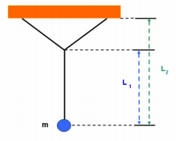
图A2-1 Y形摆装置示意
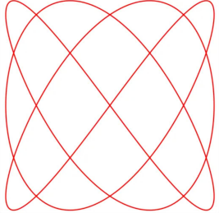
图A2-2 摆锤运动产生的李萨如图形
A3. Non-Newtonian worms 非牛顿蠕虫
If a dilatant non-Newtonian fluid (e.g. a suspension of water and cornflour) is vibrated vertically in a reservoir. When certain conditions are met, wormlike structures that rise from the surface may form. Explain and investigate this phenomenon.
将胀塑性非牛顿流体（例如玉米淀粉水悬浊液）置于容器中进行竖直振动。满足特定条件时，流体表面会形成向上隆起的蠕虫状结构。请解释并研究这一现象。
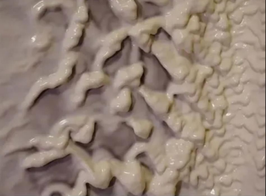
图A3-1 非牛顿流体的蠕虫状结构
A4. Seeing sound 看见声音
A thin rubber membrane is stretched over a circular frame and driven into vibration by a loudspeaker. A small mirror is attached to the membrane, and a laser beam is reflected off it onto a distant screen. Under certain conditions, the laser spot traces out complex, steady, or evolving geometric patterns. Investigate the relationship between the driving parameters, the membrane’s properties, and the resulting light patterns.
将薄橡胶膜绷紧固定在圆形框架上，用扬声器驱动薄膜振动。薄膜上粘贴一面小镜子，激光束经镜面反射后投射到远处的屏幕上。在特定条件下，激光光斑会描绘出复杂的、稳定或随时间演化的几何图案。请研究驱动参数、薄膜属性与最终光斑图案之间的关联。
B组
B1. Disc spectrometer 光盘光谱仪
Data tracks on optical media (e.g. CDs / Blu-ray discs) behave as high-quality reflection-diffraction gratings. When illuminated, these discs can disperse light into its spectral components. Construct a spectrometer using a digital optical disc. Optimise the design to maximise the resolving power and minimise optical aberrations.
光盘（CD、蓝光碟等光学介质）上的数据轨道可作为高质量的反射衍射光栅。在光照下，光盘可以将光分解为光谱组分。利用光盘搭建一台光谱仪，优化其结构，最大化分辨能力并减小光学像差。
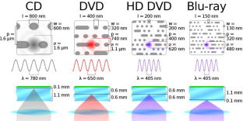
图B1-1 CD、DVD、HD DVD 与蓝光碟的轨道结构及光谱
B2. Dotted line trick 点线现象
Under certain conditions, when a piece of chalk is dragged across a blackboard, the resulting trace is not a continuous line but a periodic sequence of dots, even though the motion is uninterrupted. This can happen with other writing materials and surfaces. Investigate the physical parameters that govern this phenomenon.
在特定条件下，用粉笔在黑板上划过时，留下的痕迹并非连续线条，而是周期性的点列，即便手部的运动是连续不间断的。该现象也可发生在其他书写材料与接触面之间。研究支配这一现象的物理参数。
B3. Cold drink 冰镇饮品
A can or bottle of drink at room temperature can be cooled in a cooler containing ice. Adding salt and alcohol to the ice can increase the rate of cooling and affect the drink’s final temperature. Investigate how the relevant parameters affect the lowest achievable temperature and the maximum cooling rate.
室温下的罐装或瓶装饮品，可放入装有冰块的冷却器中降温。向冰中加入盐和酒精会提升降温速率，还会影响饮品的最终温度。研究相关参数对可达到的最低温度、最大降温速率的影响。
B4. Sinking funnel 下沉漏斗
When a long-stemmed and sufficiently heavy funnel is released vertically into water with the stem pointing downward, it undergoes a series of damped vertical oscillations while gradually sinking. Investigate the motion and stability of the sinking funnel and the conditions under which the funnel tips over.
将一个长柄、质量足够大的漏斗竖直放入水中，漏斗柄朝下。漏斗会产生一系列阻尼垂直振荡，同时逐渐下沉。请研究该下沉漏斗的运动特性与稳定性，以及漏斗发生倾覆的条件。

图B4-1 下沉漏斗

C组
C1. Singing capacitor 发声电容器
Certain types of ceramic capacitors emit an audible sound when an alternating voltage is applied across them. Investigate the characteristics of the sound produced and how they depend on relevant parameters, such as voltage, frequency, and capacitor properties.
部分类型的陶瓷电容器在两端施加交变电压时，会发出可闻声波。请研究所产生声音的特性，以及这些特性与电压、频率、电容器自身属性等相关参数的依赖关系。
C2. Falling book cover 下落的书封
A book is placed horizontally, and the partially open cover is allowed to fall. Investigate the motion of the falling book cover.
将一本书水平放置，让半开的封面自由下落。研究书封下落过程中的运动规律。
C3. Vortex pendulum 涡旋摆
A pendulum with a vertically oriented cylindrical bob is suspended above a channel of flowing water. When the bob is partially submerged, the flow may cause the pendulum to oscillate in a direction perpendicular to the flow. Explain this phenomenon and determine how it depends on relevant parameters.
一个带有竖直圆柱形摆锤的摆，悬挂在流水槽的上方。当摆锤部分浸入水中时，水流可能使摆在垂直于水流的方向上产生振荡。请解释该现象，并确定其运动特性与相关参数的依赖关系。
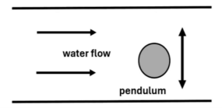
图C3-1 水流中的摆
C4. Photographic bokeh 摄影散景
Bokeh is an effect observed in photographs that show objects at different distances from the camera and have both sharp and out-of-focus areas. If a slit is placed in front of the lens of the camera, the image may have unusual anisotropic distortions in out-of-focus areas, while in-focus areas remain undistorted and sharp. Investigate how the properties and sharpness of resulting images depend on relevant parameters.
拍摄不同物距的物体时，照片会同时存在合焦清晰与失焦模糊的区域，这种视觉效果称为散景（Bokeh）。若在相机镜头前放置一条狭缝，失焦区域会出现特殊的各向异性畸变，而合焦区域仍保持清晰无畸变。请研究最终成像的特性与清晰度如何随相关参数变化。

